Set up for root password --------------

STEP---1>>># vi /etc/ssh/sshd_config t --------------using this command you can set the root password .

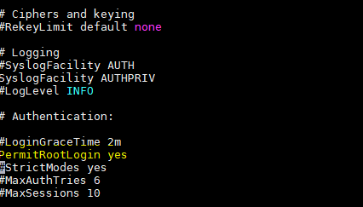

Remove  "#"  marked lines

STEP ---2>>>

removed  "#"  marked line

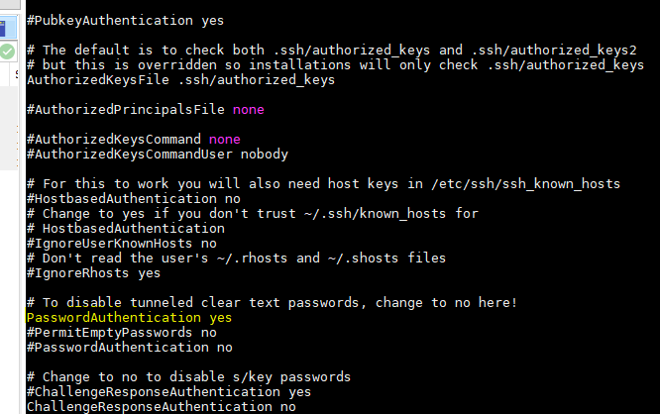

STEP---3>>Then  Run ===systemctl restart sshd ( run this command and start the ssdh service)

STEP--4>> passwd- run this command to set the pass word for root.

Example ;password (username like root)

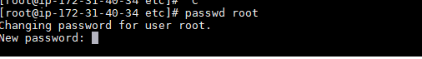

>>>NEXT  retype the pass word

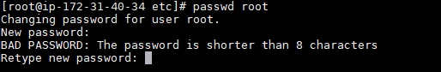

>>>>Now you can able login  root user using this root password

